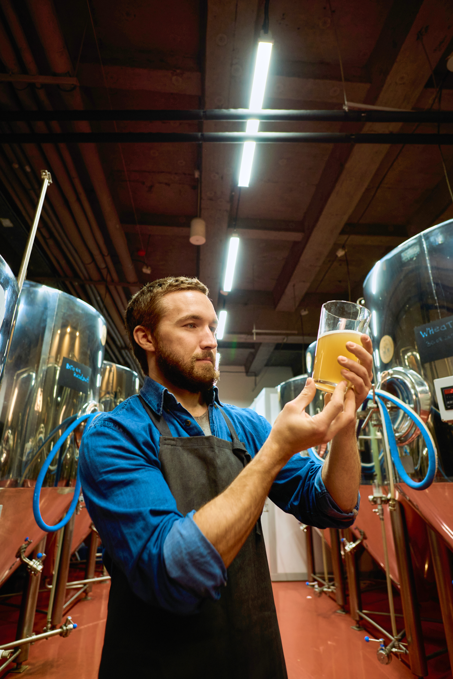  An Engineer's Guide to Building Microbrewery Facilities  Engineering Continuing Education | Abstract  This course provides a comprehensive exploration of the engineering principles and considerations involved in designing and constructing microbrewery facilities. It examines the intersection of engineering disciplines, including mechanical, electrical, civil, and environmental engineering, in the context of microbrewery development. The course guides learners through essential topics, from site selection and structural design to HVAC systems, plumbing, electrical infrastructure, and environmental compliance. Designed for engineers of all disciplines, this course equips participants with the knowledge to approach microbrewery projects with technical expertise and an appreciation for sustainability and operational efficiency.  Don Parnell, PE  Course Subject Matter Expert

Course Objectives
- Understand the site planning and structural considerations for microbrewery facilities.
- Explore the integration of HVAC, plumbing, and electrical systems specific to microbrewery operations.
- Learn about process design for brewing equipment and material handling.
- Address environmental compliance, including wastewater management and energy efficiency.
- Examine case studies to understand practical challenges and solutions in microbrewery construction.

This course is relevant to professional engineers in civil, mechanical, electrical, and environmental engineering disciplines, that are interested in facilities engineering and industrial processes within the food processing industry.

Table of Contents
Chapter 1: Introduction to Microbrewery Facilities
- History and evolution of microbreweries
- The role of engineering in microbrewery design
- Overview of the brewing process and facility requirements
Chapter 2: Site Selection and Structural Design
- Site selection criteria for microbreweries
- Zoning laws and permitting considerations
- Structural design principles for brewery buildings
- Retrofitting existing structures vs. new construction
Chapter 3: Brewing Process Design
- Process flow for brewing: milling, mashing, boiling, fermenting, and packaging
- Equipment selection: kettles, fermenters, and storage tanks
- Piping and material handling systems
- Layout optimization for efficiency and safety
Chapter 4: HVAC and Climate Control Systems
- Importance of temperature and humidity control in brewing
- Design of HVAC systems for microbrewery operations
- Energy-efficient solutions for refrigeration and heating
Chapter 5: Plumbing and Water Systems
- Potable water requirements for brewing
- Plumbing system design for cleaning, sanitation, and brewing processes
- Wastewater treatment and disposal systems
- Sustainability considerations in water usage
Chapter 6: Electrical and Power Systems
- Power requirements for brewing equipment
- Electrical safety and compliance
- Backup power systems for critical processes
- Integration of renewable energy sources
Chapter 7: Environmental Compliance and Sustainability
- Regulations for wastewater discharge and air emissions
- Energy-efficient technologies in brewing facilities
- Sustainable practices: water recycling and renewable energy adoption
- Certification programs and incentives for green breweries
Chapter 8: Project Management and Cost Analysis
- Budgeting for microbrewery projects
- Timeline and resource allocation
- Risk assessment and mitigation strategies
- Collaboration among stakeholders: engineers, architects, and brewers
Chapter 9: Case Studies in Microbrewery Construction
- Examples of successful microbrewery projects
- Lessons learned from engineering challenges
- Innovative designs in the industry
Chapter 10: Future Trends in Microbrewery Engineering
- Advances in brewing technology
- Automation and IoT integration in brewing processes
- Emerging sustainability trends and regulations

Chapter 1: Introduction to Microbrewery Facilities

1.1 The Rise of Microbreweries


Microbreweries, often characterized by their small-scale production and unique craft beers, have become a prominent part of the global beverage industry. The rise of microbreweries can be traced back to the late 20th century when consumers began seeking alternatives to mass-produced beers. Craft brewing brought an emphasis on quality, innovation, and flavor diversity, leading to the establishment of breweries that often produce fewer than 15,000 barrels annually.

Engineers have played a pivotal role in this evolution by designing systems and facilities that support small-batch brewing, while maintaining efficiency and regulatory compliance.

1.2 Role of Engineering in Microbrewery Design
The design and construction of microbrewery facilities require a multidisciplinary engineering approach. Mechanical, electrical, civil, and environmental engineers collaborate to address the unique challenges of brewing, such as temperature control, fluid dynamics, and energy efficiency.

Engineers are involved in a wide range of roles, such as:
- Structural Planning: Ensuring that the facility can support heavy brewing equipment, storage tanks, and vibration loads.
- Mechanical Systems: Designing HVAC systems to maintain precise temperatures and ensure air quality.
- Electrical Infrastructure: Providing sufficient power for equipment and integrating renewable energy sources.
- Plumbing and Water Systems: Managing water input for brewing, and output for cleaning and wastewater treatment.
- Environmental Compliance: Addressing emissions, waste disposal, and sustainable practices.

By understanding the brewing process and its requirements, engineers can create facilities that optimize production, while adhering to safety and environmental standards.

1.3 Overview of the Brewing Process
Brewing beer is a complex process that transforms raw ingredients (malted barley, hops, yeast, and water), into a finished product through a series of chemical and mechanical steps. Engineers must account for each stage in the process when designing a facility.

The stages of the brewing process are:
- Milling: Crushing malted barley to break the grain and expose starches for fermentation. Equipment must be designed for durability and minimal dust production.
- Mashing: Mixing the milled barley with heated water to convert starches into fermentable sugars. Temperature control is critical for achieving the desired sugar profile.
- Boiling: Heating the wort (liquid extracted from mashing), while adding hops to develop flavor and preserve the beer. Boilers and heat exchangers must be efficient and reliable.
- Fermentation: Introducing yeast to convert sugars into alcohol and carbon dioxide. This requires precise temperature control and clean environments to prevent contamination.
- Conditioning: Allowing the beer to mature and develop its flavors. Tanks must be equipped with insulation and pressure controls.
- Packaging: Filling bottles, cans, or kegs for distribution. Automation is often used to ensure consistency and minimize waste.

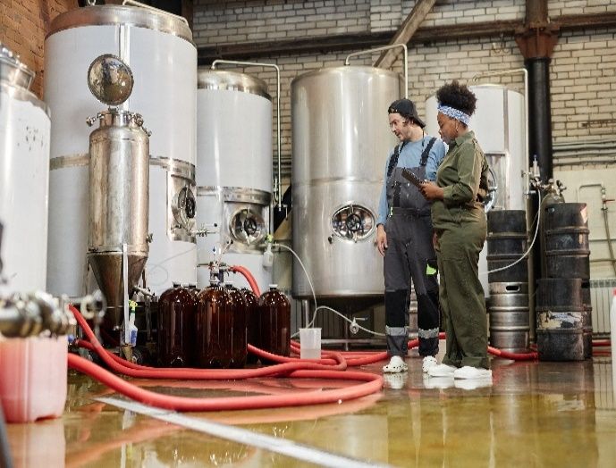
Each stage requires specialized equipment, careful monitoring, and integration of supporting systems. Engineers play a critical role in designing these systems to meet production goals and quality standards.

1.4 Facility Requirements for Microbreweries
Microbrewery facilities must be designed to accommodate brewing processes while ensuring efficiency, safety, and compliance.

Key considerations include:
- Space Utilization: Efficient layout design to allow smooth workflows and accommodate future expansion.
- Load-Bearing Structures: Supporting the weight of tanks and equipment, often exceeding several tons.
- Ventilation and Air Quality: Ensuring proper airflow to manage heat, moisture, and odors generated during brewing.
- Sanitation Systems: Installing systems for cleaning and sanitizing equipment to prevent contamination.
- Energy Efficiency: Reducing operational costs through efficient insulation, heat recovery systems, and renewable energy sources.

By addressing these requirements, engineers create facilities that are not only functional but also capable of producing high-quality craft beer.

1.5 Summary
Microbreweries, known for their small-scale production and diverse craft beers, have grown significantly as consumers seek quality and innovation over mass-produced options. Engineers play a crucial role in the design and operation of these facilities, ensuring efficiency, safety, and compliance through a multidisciplinary approach.

The next chapter will examine site selection and structural design for microbreweries.

Chapter 2: Site Selection and Structural Design

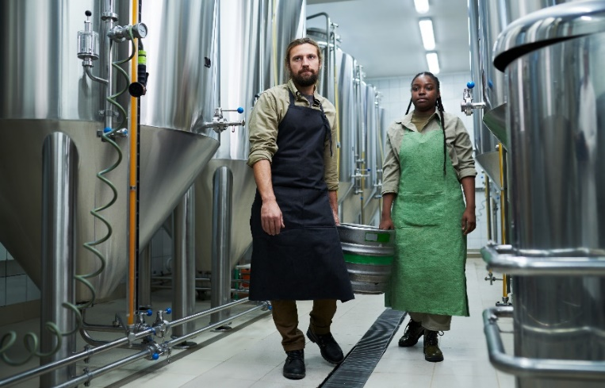
2.1 Importance of Site Selection
The choice of location for a microbrewery is a foundational decision that impacts every aspect of its operation, from production efficiency to customer accessibility.

Site selection involves evaluating factors, such as zoning regulations, infrastructure availability, environmental impact, and market proximity.

An ideal site aligns with the following considerations:
- Zoning Compliance: Local zoning laws dictate where breweries can operate. Industrial or mixed-use zones are typically favorable due to their flexibility for manufacturing activities.
- Infrastructure Availability: Access to utilities, such as potable water, electricity, and wastewater systems is essential. Reliable transportation networks for distribution and supply chain management are equally critical.
- Environmental Impact: The brewery’s footprint should minimize environmental disturbances, particularly in areas with ecological sensitivity. This includes evaluating wastewater disposal, emissions, and resource consumption.
- Market Accessibility: Proximity to target markets, whether urban centers or tourist destinations, ensures steady foot traffic and brand visibility.

By addressing these factors during the planning phase, engineers can optimize the brewery’s operational and financial performance while adhering to local regulations.

2.2 Structural Design Principles for Brewery Facilities
The structural design of a microbrewery facility must accommodate heavy equipment, dynamic processes, and stringent safety standards. Engineers focus on the following structural elements.

Load-Bearing Design
Brewing equipment, such as fermentation tanks and kettles, can weigh several tons, especially when filled with liquids. Structural engineers ensure that:
- Floors are reinforced to withstand concentrated loads.
- Load distribution systems prevent uneven settling or cracking.
- Elevated platforms are designed for safe access to equipment.

Material Selection
Durable and hygienic materials are crucial for brewery construction. Common materials include:
- Concrete: Ideal for floors due to its strength and resistance to moisture.
- Stainless Steel: Used in piping, tanks, and finishes for its corrosion resistance and ease of cleaning.
- Epoxy Coatings: Applied to floors and walls to create impermeable, easy-to-clean surfaces.

Ventilation and Air Circulation
Breweries generate heat, moisture, and odors during production. Structural engineers collaborate with mechanical engineers to design ventilation systems that:
- Maintain air quality and temperature stability.
- Prevent condensation, which can lead to mold growth.
- Ensure compliance with occupational safety standards.

Seismic and Wind Considerations
In regions prone to seismic activity or high winds, structural designs must incorporate additional reinforcements to protect against natural forces. These considerations include:
- Anchoring large equipment to prevent tipping.
- Reinforcing walls and roofs to withstand lateral forces.

2.3 Retrofitting Existing Structures vs. New Construction
Microbreweries are often established in retrofitted buildings, such as old warehouses or industrial spaces. While retrofitting offers cost savings and sustainability benefits, it also presents challenges.

Retrofitting Existing Structures
- Advantages: Preserving historical character, reducing construction waste, and utilizing existing infrastructure.
- Challenges: Adapting to outdated layouts, addressing structural deficiencies, and meeting modern building codes.

New Construction
- Advantages: Customizing the layout to meet specific brewing needs, integrating modern materials and technologies, and ensuring compliance with all regulations from the outset.
- Challenges: Higher upfront costs and longer construction timelines.

Engineers must evaluate the feasibility of retrofitting versus new construction based on project goals, budget, and site conditions.

2.4 Summary
Site selection and structural design are critical elements in the planning and construction of a microbrewery, directly influencing its operational efficiency, compliance, and market success.

Ideal sites provide access to essential utilities, transportation networks, and minimize ecological disturbances, while being strategically positioned near target markets. Structural design principles prioritize the facility’s ability to support heavy brewing equipment, ensure durability, and maintain safety standards.

Chapter 3: Brewing Process Design

The brewing process involves converting raw ingredients into finished beer through a series of controlled chemical and mechanical operations.

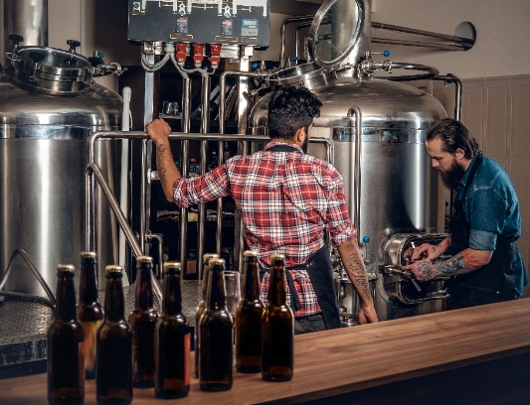
Engineers designing microbrewery facilities must understand the nuances of this process to optimize production, ensure quality, and meet regulatory standards. A well-engineered brewing system integrates equipment, workflow, and resource management to maximize efficiency while minimizing waste and energy consumption.

3.1 Key Stages of the Brewing Process
Each stage of the brewing process requires specific equipment and environmental conditions.

Engineers must design systems that support these stages seamlessly.

Stage 1: Milling
- Purpose: Crush malted barley to expose starches for fermentation.
- Equipment: Roller mills or hammer mills designed for precision and durability.
- Engineering Considerations: Implementing dust mitigation systems to maintain air quality and reduce fire hazards, as well as ensuring proper material flow to subsequent processes.

Stage 2: Mashing
- Purpose: Mix milled grain with hot water to convert starches into fermentable sugars.
- Equipment: Mash tuns with agitators and precise temperature control mechanisms.
- Engineering Considerations: Utilizing heat recovery systems to improve energy efficiency, and integrating systems to monitor and adjust water-to-grain ratios for optimal sugar conversion.

Stage 3: Lautering
- Purpose: Separate the liquid wort from spent grain.
- Equipment: Lauter tuns with false bottoms to facilitate filtration.
- Engineering Considerations: Designing systems to transport spent grain for sustainable uses, such as animal feed or biofuel production, while optimizing filtration speed and efficiency.

Stage 4: Boiling
- Purpose: Sterilize the wort and extract flavor from hops.
- Equipment: Kettles equipped with heating elements and vapor condensers.
- Engineering Considerations: Incorporating energy-efficient boiler and steam management systems to minimize heat loss and emissions.

Stage 5: Cooling and Whirlpooling
- Purpose: Rapidly cool the wort and remove hop solids and proteins.
- Equipment: Plate heat exchangers and whirlpool tanks.
- Engineering Considerations: Designing closed-loop cooling systems to conserve water, and integrating sediment removal mechanisms to enhance wort clarity.

Stage 6: Fermentation
- Purpose: Convert sugars into alcohol and carbon dioxide using yeast.
- Equipment: Fermentation tanks with temperature controls and clean-in-place (CIP) systems.
- Engineering Considerations: Ensuring sterile conditions, preventing contamination, and maintaining precise environmental controls for yeast health.

Stage 7: Conditioning
- Purpose: Allow the beer to mature and develop its flavor.
- Equipment: Bright beer tanks with pressure and temperature controls.
- Engineering Considerations: Designing systems to minimize oxygen exposure, ensuring consistency in carbonation, and facilitating sampling for quality assurance.

Stage 8: Packaging
- Purpose: Prepare beer for distribution in kegs, bottles, or cans.
- Equipment: Automated packaging lines, pasteurization systems, and labeling machines.
- Engineering Considerations: Reducing product loss during filling, optimizing line speed for throughput, and incorporating recyclable or sustainable packaging materials.

3.2 Process Flow and Layout Optimization
Efficient brewing operations depend on a well-organized process flow and facility layout.

Engineers optimize brewery layouts by addressing:
- Cross-Contamination Prevention: Physical separation of raw ingredient handling from finished product zones.
- Material Movement Efficiency: Designing linear workflows to minimize transport distances, for ingredients and products, and delays.
- Safety and Accessibility: Ensuring the proper placement of equipment and pipelines to enable easy accessibility for operation and maintenance.
- Scalability: Designing flexibility in the layouts to accommodate future expansions or upgrades.

3.3 Energy Efficiency and Resource Management
Brewing is an energy-intensive process, particularly during mashing, boiling, and cooling stages.

Engineers must integrate resource-saving technologies, such as:
- Heat Recovery Systems: Capturing waste heat from boiling or mashing for reuse in other stages, such as preheating water.
- Water Recycling: Capturing and repurposing process water for cleaning or secondary heating tasks.
- Efficient Insulation: Reducing energy loss in tanks, pipes, and processing equipment.

3.4 Material Handling Systems
Efficient material handling is essential for maintaining consistent and smooth production. This includes:
- Ingredient Storage: Designing silos and storage areas for grains, hops, and adjuncts with controlled conditions.
- Piping Systems: Engineering robust pipelines to ensuring proper fluid dynamics for transferring liquids between stages, and minimizing blockages.
- Automated Systems: Incorporating conveyors, robotic systems, and automated controls to streamline ingredient handling and packaging.

By addressing these factors, engineers ensure that the brewing process is not only efficient but also capable of producing high-quality beer consistently.

3.5 Summary
The brewing process relies on precise engineering to convert raw ingredients into high-quality beer efficiently and sustainably. Engineers design systems for each stage of the process, ensuring optimal performance and minimal waste.

Through thoughtful integration of technology and engineering expertise, microbreweries achieve reliable production and consistent product quality.

Chapter 4: HVAC and Climate Control Systems

Effective climate control is vital in microbreweries to maintain the precision and consistency required for the brewing process. Temperature, humidity, and air quality significantly influence the quality of the beer, the efficiency of brewing operations, and the comfort of personnel working in the facility.

Heating, Ventilation, and Air Conditioning (HVAC) systems in microbreweries are specifically designed to manage these parameters, ensuring optimal environmental conditions for each stage of production.

4.1 Importance of Climate Control in Microbreweries
Climate control impacts critical brewing processes, such as fermentation, maturation, and storage. Proper climate control also preserves ingredient quality, such as malt and hops, by maintaining ideal storage conditions.

Fermentation tanks require precise temperature control to ensure yeast activity remains within desired ranges for producing consistent flavors and alcohol content. Excessive humidity can lead to condensation on surfaces, fostering microbial growth and potential contamination. In addition, improper air circulation can allow odors and heat buildup to interfere with production and worker safety.

Maintaining optimal environmental conditions is critical in a microbrewery, as temperature and humidity directly impact the brewing process and product quality.

4.2 HVAC System Design for Microbreweries
Designing HVAC systems for microbreweries involves tailoring solutions to address unique brewing requirements.

They play a vital role in:
- Ensuring consistent fermentation conditions.
- Preventing contamination caused by excess humidity or airborne particles.
- Controlling temperatures in storage and packaging areas.

Engineers play a key role in this process by designing, implementing, and maintaining systems that support brewery operations effectively and sustainably.

Temperature Control in Brewing Processes
Temperature regulation is particularly critical in the fermentation and conditioning stages of beer production.

- Fermentation Tanks: Yeast activity is highly sensitive to temperature fluctuations. Precise control is required to ensure consistent fermentation rates and flavor profiles.
- Storage Areas: Refrigeration systems maintain ideal conditions for storing raw ingredients and finished products.
- Packaging Zones: Temperature stability prevents condensation, which can compromise product quality and labeling.

HVAC systems for microbreweries often include zoned temperature controls to maintain specific conditions for each production areas.

Humidity Management
The brewing process generates significant moisture, particularly during mashing, boiling, and cleaning.

Excess humidity can lead to:
- Mold and mildew growth, which can contaminate the product and damage the facility.
- Corrosion of equipment and building materials.
- Reduced air quality for workers.

Dehumidifiers and ventilation systems are integral to controlling moisture levels. Engineers must calculate the brewery’s moisture load to design effective systems that prevent condensation and maintain OSHA-compliant working conditions.

Ventilation and Air Quality
Engineers ensure that systems are equipped with exhaust fans, dehumidifiers, and air filtration units to maintain safe and clean air circulation. Proper ventilation is essential for maintaining air quality, and removing heat, moisture, odors, and volatile organic compounds (VOCs) generated during brewing.

Key considerations include:
- Exhaust Systems: Removing heat and steam from the boiling stage to maintain a comfortable working environment.
- Odor Control: Employing filtration systems to mitigate odors and comply with local regulations.
- Airflow Optimization: Ensuring consistent air circulation to prevent stagnant zones and contamination risks.

Ventilation systems must balance air exchange rates to maintain pressure equilibrium while minimizing energy consumption.

Refrigeration and Cooling Systems
Cooling systems are vital for fermentation, storage, and packaging. Common systems include:
- Glycol Chillers: Used to regulate the temperature of fermentation tanks and bright beer tanks. Engineers must size these systems accurately to meet the brewery’s cooling demand.
- Walk-In Coolers: Designed for bulk storage of raw ingredients and kegs. Proper insulation and temperature controls reduce energy costs.
- Heat Exchangers: Rapidly cooling wort after the boiling stage to prepare it for fermentation. Plate heat exchangers are commonly used for their efficiency and compact design.

Load-bearing and Layout Considerations
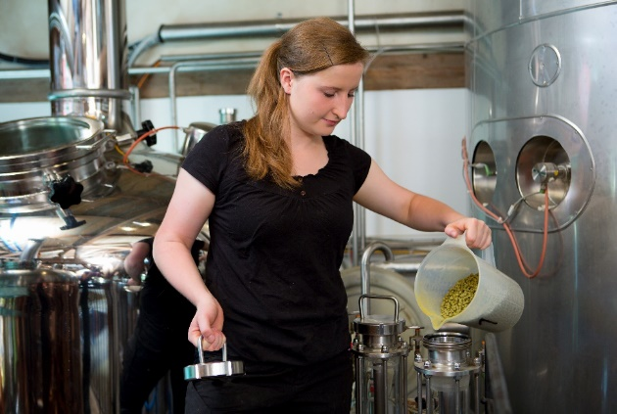
HVAC equipment, such as chillers and air handling units, must be positioned to maximize efficiency without disrupting brewery workflows. Structural engineers ensure that roofs or floors can bear the weight of heavy HVAC units, especially in compact microbrewery layouts.

Sanitation and Compliance
Proper airflow design helps reduce cross-contamination risks by isolating raw material zones from fermentation and packaging areas. Engineers ensure that HVAC systems meet regulatory standards for food-grade facilities.

Engineers designing HVAC systems for microbreweries must account for the unique challenges posed by heat, moisture, and airflow in brewing operations.

4.3 Energy Efficiency Solutions for Refrigeration and Heating
Energy efficiency is a priority in microbrewery climate control due to the energy-intensive nature of brewing, particularly in HVAC and refrigeration systems. Engineers implement solutions to reduce energy consumption and operational costs, without compromising systems performance.

Key methods to reduce energy usage include:
- Heat Recovery: Capturing waste heat from boiling and fermentation processes, such as boiling or wort cooling, to reduce reliance on external heating sources, and redirected to preheat water for cleaning or mashing. High-efficiency boilers and on-demand water heaters, are designed to minimize energy loss during heating operations.


- Refrigeration Systems: Glycol chillers are commonly used to cool fermentation tanks and conditioning areas, with engineers optimizing their operation through variable-speed compressors and advanced control systems. Waste heat generated by refrigeration units can be captured and repurposed for tasks such as water preheating.

- Variable Frequency Drives (VFDs): VFDs allow precise control of motor speeds in equipment, such as pumps, compressors, and fans, enabling systems to operate at the required capacity. It adjusts fan and pump speeds based on real-time demand. Engineers integrate VFDs into HVAC systems, glycol chillers, and boiler feed pumps to optimize energy efficiency , and ensure consistent performance throughout the brewing process.

- Insulation: Proper insulation of tanks, pipes, and building envelopes reduces heat transfer, maintaining consistent temperatures, while lowering energy demands. Using high-performance materials helps to minimize heat loss in piping and storage tanks. Engineers design airflow systems to minimize energy waste by balancing supply and exhaust air volumes.

- Renewable Energy Integration: Incorporating solar panels or geothermal systems to offset HVAC energy consumption, further reducing the microbrewery’s carbon footprint.

4.4 System Integration and Automation
Modern HVAC systems often incorporate automation technologies to enhance performance and reduce labor requirements.

Features include:
- Sensors and Controls: Monitoring temperature, humidity, and airflow in real-time.
- Programmable Systems: Automating temperature adjustments based on production schedules.
- IoT Integration: Providing remote monitoring and diagnostics to prevent downtime and optimize energy usage.

By carefully designing and integrating HVAC systems, engineers can create an environment that supports efficient brewing operations while minimizing energy costs and environmental impact.

4.5 Summary
HVAC and climate control systems are essential for ensuring the quality, safety, and efficiency of brewing operations in microbreweries. Engineers play a critical role in designing tailored HVAC solutions that maintain precise temperature, humidity, and air quality conditions, while optimizing energy efficiency.

Modern HVAC designs not only support consistent beer production, but also reduce environmental impact and operational costs. By prioritizing sustainability and precision, engineers enable microbreweries to achieve both high-quality output and energy-efficient operations.

Chapter 5: Plumbing and Water Systems

Plumbing systems are fundamental to microbrewery operations, ensuring a reliable supply of water for brewing, cleaning, and sanitation. Engineers must design plumbing systems that meet the brewery’s diverse water demands, while maintaining regulatory compliance and promoting sustainability. Properly engineered systems contribute to operational efficiency, product quality, and environmental stewardship.

5.1 Water Requirements for Brewing
Water is the most significant ingredient in beer, comprising up to 95% of its volume. Its quality and treatment are critical for achieving the desired flavor and consistency.

Key considerations include:
- Potable Water Supply: Water used in brewing must meet high purity standards to prevent contamination and off-flavors.
- Water Chemistry: Adjusting mineral content and pH levels to match specific beer styles. For instance, soft water is preferred for lagers, while hard water enhances the flavor of stouts and ales.
- Filtration and Treatment: Installing filtration systems to remove impurities, such as chlorine, heavy metals, and microorganisms. Reverse osmosis systems are commonly used for precise water treatment.

5.2 Plumbing System Design for Brewing Operations
Engineers must design plumbing systems to handle the brewery’s water demands efficiently and hygienically.

Key considerations include:
- Water Distribution: Ensuring consistent water pressure and flow rates across brewing stages, from mashing to cleaning.
- Temperature Control: Providing hot and cold water as needed for processes such as mashing (hot water), and wort cooling (cold water).
- Sanitary Piping: Using materials like stainless steel or food-grade plastics to prevent contamination and facilitate cleaning.
- Backflow Prevention: Installing backflow preventers to protect potable water supplies from contamination by process water or cleaning agents.

5.3 Wastewater Treatment and Disposal
Breweries generate significant volumes of wastewater, often laden with organic matter, cleaning chemicals, and spent grains. Engineers must design systems to manage and treat this effluent responsibly.

Key considerations include:
- Wastewater Characteristics: Brewery wastewater typically has high biochemical oxygen demand (BOD) and suspended solids, requiring pretreatment before discharge.
- Pretreatment Systems: Installing technologies such as settling tanks, anaerobic digesters, or dissolved air flotation (DAF) systems to remove solids and reduce BOD levels.
- Discharge Compliance: Adhering to local regulations governing wastewater discharge into municipal systems or natural water bodies.
- Recycling and Reuse: Designing systems to reuse treated water for non-potable applications, such as irrigation or equipment cleaning.

Cleaning and Sanitation Systems
Sanitation is critical in brewing to maintain product quality and prevent contamination. Engineers design cleaning systems that:
- Automate Cleaning Processes: Incorporating clean-in-place (CIP) systems to clean tanks and piping without disassembly.
- Use Sustainable Practices: Optimizing the use of water and cleaning agents to minimize waste and environmental impact.
- Separate Cleaning Streams: Designing plumbing to handle cleaning chemicals separately from brewing processes to prevent cross-contamination.

5.4 Sustainability Considerations in Plumbing Systems
Modern breweries increasingly prioritize sustainability in water management. Engineers can integrate environmentally friendly practices, such as:
- Rainwater Harvesting: Capturing and treating rainwater for use in non-potable applications.
- Gray Water Recycling: Reusing lightly contaminated water from cleaning or cooling for irrigation or secondary processes.
- Water Conservation Technologies: Installing low-flow fixtures and monitoring systems to identify and address leaks or inefficiencies.

5.5 Integration with Overall Facility Design
Plumbing systems in microbreweries must integrate seamlessly with other facility systems, including HVAC, electrical, and brewing equipment. This requires careful coordination among engineering disciplines to:
- Ensure compatibility between plumbing materials and brewing processes.
- Minimize energy consumption by integrating heat recovery and water recycling systems.
- Optimize layout design for accessibility and maintenance.

By addressing these factors, engineers can design plumbing systems that support efficient, sustainable, and high-quality brewing operations.

5.6 Summary
Plumbing systems are integral to microbrewery operations, ensuring a consistent and reliable supply of water for brewing, cleaning, and sanitation, while managing wastewater responsibly.

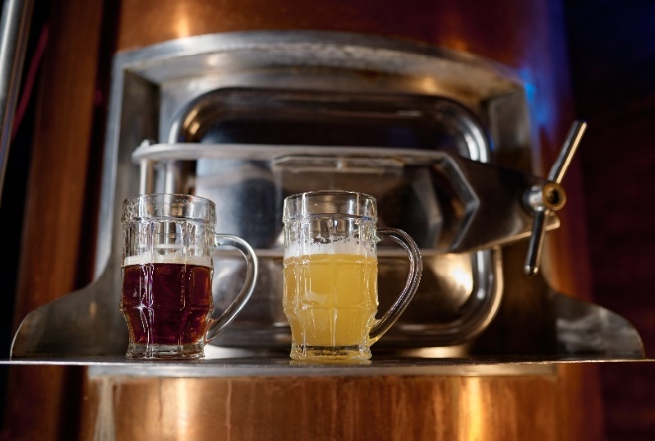
Engineers play a critical role in designing these systems to meet diverse water demands, enhance operational efficiency, and support sustainability.

By ensuring seamless integration of plumbing with other facility systems, engineers can leverage advanced technologies, like heat recovery and recycling, to reduce energy and resource consumption.

Chapter 6: Electrical and Power Systems

Electrical systems are the backbone of a microbrewery, powering essential brewing equipment, HVAC systems, lighting, and automation technologies. Engineers must design these systems to meet the brewery’s operational demands, while ensuring safety, efficiency, and reliability. Proper planning and integration of electrical infrastructure are critical to avoiding power interruptions, equipment failures, and safety hazards.

6.1 Power Requirements for Brewing Equipment
Brewing processes involve various electrically powered equipment, each with specific power demands.

Essential equipment in microbreweries with power requirements include:
- Milling: High-torque motors for grinding malted barley.
- Heating Systems: Electric boilers and heating elements for mashing and boiling.
- Cooling Systems: Glycol chillers and heat exchangers for precise temperature control.
- Fermentation and Conditioning: Agitators, pumps, and temperature control units.
- Packaging Lines: Motors and automation systems for bottling, canning, and labeling.


Engineers must calculate the total power requirements based on equipment specifications and operational cycles, ensuring adequate capacity and avoiding overloading the system.

6.2 Electrical Safety and Compliance
Microbrewery electrical systems must comply with national and local electrical codes to protect personnel and equipment.

Key safety considerations include:
- Grounding and Bonding: Ensuring that all electrical components are properly grounded to prevent electrical shocks.
- Explosion-Proof Fixtures: Using explosion-proof electrical enclosures in areas with flammable substances, such as grain storage and milling zones.
- Circuit Protection: Installing circuit breakers and surge protectors to safeguard equipment from power surges and short circuits.
- Lockout/Tagout Procedures: Providing protocols for safely de-energizing equipment during maintenance.

6.3 Backup Power Systems for Critical Processes
Power outages can disrupt brewing processes, leading to product loss and equipment damage.

Backup power systems provide critical support:
- Generators: Diesel or natural gas generators ensure uninterrupted power supply during outages.
- Uninterruptible Power Supply (UPS): Protecting sensitive equipment, such as automation controllers, from short-term power interruptions.
- Load Prioritization: Designing systems to prioritize essential equipment during outages, such as refrigeration and fermentation controls.

6.4 Integration of Renewable Energy Sources
Many modern microbreweries incorporate renewable energy sources to reduce operating costs and environmental impact.

Common options include:
- Solar Panels: Generating electricity for lighting, heating, and auxiliary systems.
- Wind Turbines: Supplementing power needs in regions with high wind availability.
- Energy Storage Systems: Using batteries to store excess energy for later use, ensuring a consistent power supply.

Engineers must assess the feasibility of integrating renewables based on site-specific conditions, such as sunlight exposure or wind patterns.

6.5 Electrical Distribution Systems
A brewery’s electrical distribution system must efficiently and safely deliver power to all equipment and systems.

Key design considerations include:
- Subpanels and Circuits: Installing subpanels to distribute power across production zones, minimizing voltage drops and circuit overloads.
- Conduit and Wiring: Using industrial-grade conduits and wiring to withstand environmental factors such as moisture, heat, and chemical exposure.
- Motor Control Centers (MCCs): Centralizing control for motors and automation systems, allowing for efficient monitoring and maintenance.
- Lighting Systems: Designing energy-efficient lighting for production areas, storage zones, and tasting rooms, incorporating LED fixtures to reduce energy consumption.

6.6 Automation and Smart Technologies
Automation enhances brewery efficiency by reducing labor requirements and ensuring process consistency. Electrical systems must support automation technologies, such as:
- Programmable Logic Controllers (PLCs): Managing brewing cycles, including temperature adjustments and ingredient additions.
- Sensors and Actuators: Monitoring parameters such as temperature, pressure, and flow rates, and adjusting equipment operations accordingly.
- IoT Integration: Enabling remote monitoring and control of equipment through cloud-based systems.

6.7 Energy Efficiency in Electrical Systems
Energy-efficient electrical design reduces operational costs and environmental impact. Engineers do this by incorporating:
- Variable Frequency Drives (VFDs): Adjusting motor speeds to match real-time demand, improving energy efficiency.
- Power Factor Correction: Installing capacitor banks to optimize power usage and reduce utility charges.
- Load Scheduling: Timing energy-intensive processes during off-peak hours to lower electricity costs.

6.8 Coordination with Other Systems
Electrical systems must integrate seamlessly with HVAC, plumbing, and brewing equipment. Engineers ensure compatibility by:
- Collaborating with other disciplines during the design phase.
- Designing centralized control systems for streamlined operation and troubleshooting.
- Providing adequate power capacity for future equipment upgrades or expansions.
By addressing these factors, engineers create robust, efficient, and safe electrical systems that support all aspects of microbrewery operations.

6.9 Summary

Electrical systems are essential for powering microbrewery operations, including brewing equipment, HVAC, lighting, and automation. Engineers ensure these systems are efficient, reliable, and safe.

This is done by calculating power demands, implementing safety measures, and designing robust distribution systems. Backup power systems protect against outages, while renewable energy sources reduce costs and environmental impact.

Chapter 7: Environmental Compliance and Sustainability

Microbreweries, like all manufacturing facilities, must adhere to environmental regulations to mitigate their ecological impact. Compliance ensures the brewery meets legal requirements for waste management, emissions, and resource usage. Beyond compliance, adopting sustainable practices enhances operational efficiency, reduces costs, and aligns with consumer expectations for environmentally responsible businesses.

7.1 Regulatory Framework for Microbreweries
Environmental compliance involves adhering to a range of regulations at federal, state, and local levels.

Key regulatory areas include:
- Wastewater Discharge: The Clean Water Act (CWA) regulates the discharge of brewery effluent into water bodies or municipal sewer systems. Permits may require pretreatment to reduce biochemical oxygen demand (BOD) and suspended solids.
- Air Emissions: The Clean Air Act (CAA) governs emissions from boilers, heating systems, and volatile organic compounds (VOCs) produced during brewing.
- Solid Waste Management: Regulations dictate the disposal of spent grain, packaging materials, and other solid waste. Many breweries recycle spent grain as animal feed or biofuel.
- Energy Usage Reporting: Certain jurisdictions require reporting on energy consumption and greenhouse gas (GHG) emissions.

Engineers must design systems that not only meet these requirements but also anticipate future regulatory changes.

7.2 Wastewater Management in Microbreweries
Wastewater from brewing operations contains organic matter, cleaning chemicals, and spent yeast, requiring effective treatment to meet discharge standards.

Key engineering considerations include:
- Effluent Characterization: Analyzing wastewater composition to determine treatment needs, such as reducing BOD, chemical oxygen demand (COD), and pH adjustment.
- Pretreatment Systems: Installing settling tanks, anaerobic digesters, or aerobic bioreactors to remove solids and organic pollutants.
- Recycling and Reuse: Designing systems to reuse treated water for cleaning or irrigation, reducing overall water consumption.

By addressing wastewater management during facility design, engineers ensure compliance while minimizing costs and environmental impact.

7.3 Air Quality and Emission Controls
Brewing processes produce emissions such as carbon dioxide (CO₂) during fermentation and VOCs from boiling hops.

Effective air quality management includes:
- CO₂ Recovery Systems: Capturing and reusing CO₂ from fermentation for carbonation or other processes.
- Ventilation and Filtration: Using filtration systems to control odors and capture VOCs before release into the atmosphere.
- Efficient Boilers: Upgrading to low-emission boilers or integrating renewable energy sources to reduce GHG emissions.

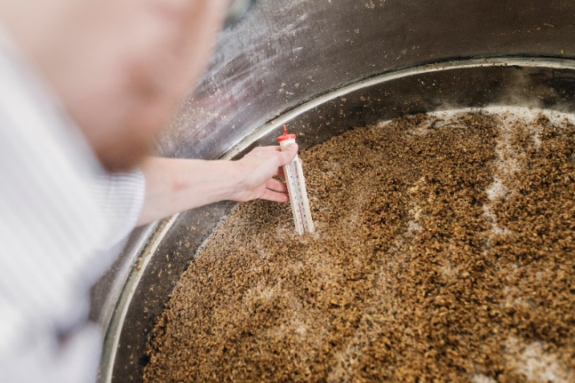
7.4 Solid Waste and Byproduct Management
Breweries generate significant quantities of solid waste, including spent grain, hops, and packaging materials.

Engineers can implement sustainable waste management practices, such as:
- Spent Grain Recycling: Partnering with farms to use spent grain as livestock feed or compost.
- Hops and Yeast Reuse: Exploring opportunities to repurpose brewing byproducts in biofuel production or as soil amendments.
- Packaging Waste Reduction: Encouraging reusable keg systems and recycling programs for bottles and cans.

7.5 Energy Efficiency and Renewable Energy Integration
Brewing is energy-intensive, particularly during mashing, boiling, and cooling processes.

Engineers can reduce energy consumption by:
- Heat Recovery Systems: Capturing waste heat from boiling or chilling for reuse in other stages of brewing.
- Insulation and Building Design: Minimizing energy loss through high-performance insulation and energy-efficient facility layouts.
- Renewable Energy: Incorporating solar panels, wind turbines, or geothermal systems to offset energy usage.

7.6 Water Conservation and Sustainable Practices
Water usage is a significant concern for breweries, often exceeding 7 gallons of water per gallon of beer produced.

Sustainable practices include:
- Water Audits: Conducting audits to identify inefficiencies and opportunities for conservation.
- Low-Flow Fixtures: Installing low-flow nozzles and fixtures in cleaning and sanitation systems.
- Gray Water Recycling: Reusing lightly contaminated water for non-potable applications, such as irrigation or equipment cleaning.

7.7 Certification Programs and Incentives
Sustainable practices can earn breweries recognition and financial incentives through programs, such as:
- LEED Certification: Achieving Leadership in Energy and Environmental Design certification for environmentally friendly building design.
- B Corp Certification: Demonstrating a commitment to social and environmental performance.
- Tax Incentives and Grants: Qualifying for incentives that offset the costs of renewable energy installations or sustainable upgrades.

7.8 The Business Case for Sustainability
In addition to regulatory compliance, sustainability offers tangible benefits:
- Cost Savings: Reducing water and energy consumption lowers operational expenses.
- Brand Loyalty: Aligning with consumer preferences for environmentally responsible products.
- Resilience: Preparing for stricter environmental regulations and resource scarcity in the future.

By designing systems that prioritize sustainability, engineers can position microbreweries as leaders in environmental responsibility and operational efficiency.

7.9 Summary
Environmental compliance and sustainability are essential for microbreweries to minimize ecological impact, meet legal requirements, and align with consumer expectations.

Engineers play a critical role in designing systems that address wastewater discharge, air emissions, solid waste management, energy efficiency, and water conservation. Compliance with regulations, such as the CWA and CAA, involves pretreatment systems for wastewater, Co2 recovery technologies, and low-emission boilers to reduce environmental impact.

By integrating compliance with sustainability, engineers position microbreweries for long-term operational success and environmental stewardship.

Chapter 8: Project Management and Cost Analysis

Effective project management is critical for the successful design and construction of a microbrewery.


Engineers must balance technical, financial, and operational considerations to deliver a facility that meets quality, schedule, and budget requirements.

Project management ensures coordination among stakeholders, optimizes resource allocation, and mitigates risks throughout the project lifecycle.

8.1 Key Phases of Microbrewery Project Management
Microbrewery projects typically follow a structured sequence of phases.

Phase 1: Feasibility Study and Concept Development
- Objective: Determine the technical and financial viability of the project.
- Activities:
  - Conducting market research to assess demand and competition.
  - Evaluating site suitability based on zoning, infrastructure, and environmental factors.
  - Estimating initial costs and return on investment (ROI).
- Deliverables: Preliminary project scope, conceptual designs, and feasibility report.

Phase 2: Design and Engineering
- Objective: Develop detailed plans for the brewery’s construction and operation.
- Activities:
  - Creating architectural and engineering designs.
  - Selecting brewing equipment and specifying supporting systems (HVAC, plumbing, electrical).
  - Ensuring compliance with building codes and environmental regulations.
- Deliverables: Finalized blueprints, equipment specifications, and permit applications.

Phase 3: Procurement and Contracting
- Objective: Source materials, equipment, and services.
- Activities:
  - Soliciting bids from contractors and suppliers.
  - Evaluating proposals for cost, quality, and delivery timelines.
  - Negotiating contracts and securing procurement agreements.
- Deliverables: Signed contracts and a detailed procurement schedule.

Phase 4: Construction and Installation
- Objective: Build the brewery facility and install equipment.
- Activities:
  - Site preparation, including grading, excavation, and utility connections.
  - Structural construction, equipment installation, and system integration.
  - Conducting inspections to ensure compliance with safety and quality standards.
- Deliverables: Completed facility ready for commissioning.

Phase 5: Commissioning and Handover
- Objective: Test systems and prepare the facility for full operation.
- Activities:
  - Verifying the performance of brewing equipment and supporting systems.
  - Training personnel on operation and maintenance.
  - Addressing any deficiencies identified during testing.
- Deliverables: Operational microbrewery and final project documentation.

8.2 Cost Analysis for Microbrewery Projects
Accurate cost estimation is essential to ensure the financial feasibility of a microbrewery. Engineers must account for both capital and operational expenditures.

Capital Expenditures (CapEx)
- Land Acquisition and Site Preparation: Costs for purchasing the site, clearing, grading, and installing utilities.
- Construction and Materials: Expenses for building structures, flooring, and interior finishes.
- Equipment Procurement: Costs for brewing equipment, storage tanks, piping, and control systems.
- Permits and Fees: Expenses for obtaining zoning approvals, building permits, and environmental compliance certifications.

Operational Expenditures (OpEx)
- Utilities: Costs for water, electricity, and natural gas consumption.
- Labor: Wages for brewery personnel, including brewers, technicians, and administrative staff.
- Maintenance: Regular servicing of equipment and facility upkeep.
- Raw Materials: Costs for malt, hops, yeast, and packaging materials.

8.3 Budgeting and Resource Allocation
Engineers use detailed cost breakdowns to develop realistic budgets and allocate resources effectively.

Common tools include:
- Cost Estimation Software: Generating detailed cost models based on industry benchmarks.
- Work Breakdown Structures (WBS): Dividing the project into manageable components for cost tracking.
- Contingency Reserves: Allocating funds for unforeseen expenses, typically 10-20% of the total budget.

8.4 Risk Assessment and Mitigation Strategies
Microbrewery projects face various risks that can impact timelines and budgets. Engineers identify and mitigate these risks through:
- Thorough Planning: Conducting feasibility studies and site assessments to minimize uncertainties.
- Stakeholder Communication: Maintaining clear communication channels to address issues promptly.
- Flexible Design: Allowing for design modifications to adapt to site-specific challenges.
- Insurance Coverage: Securing policies to protect against construction delays, equipment failures, and liability claims.

8.5 Collaboration Among Stakeholders
Successful microbrewery projects require collaboration between multiple stakeholders, including:
- Engineers and Architects: Designing functional and aesthetically appealing facilities.
- Brewers: Providing input on process requirements and equipment preferences.
- Contractors and Suppliers: Ensuring timely delivery of materials and adherence to quality standards.
- Regulatory Authorities: Overseeing compliance with building codes, environmental regulations, and health standards.

Engineers play a central role in coordinating these efforts, ensuring that all parties work toward shared goals.

8.6 Summary
Effective project management is essential for designing and building a microbrewery, ensuring projects meet quality, budget, and schedule goals. Key phases include feasibility studies, detailed design, procurement, construction, and commissioning.

Risks are mitigated through careful planning, flexible designs, and stakeholder collaboration, including input from brewers, contractors, and regulators. By coordinating these actions, engineers can deliver functional, complaint, and efficient facilities.

Chapter 9: Case Studies in Microbrewery Construction

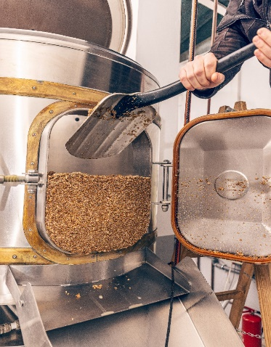
Case studies provide valuable insights into the practical challenges and innovative solutions associated with microbrewery construction projects.

By examining real-world examples, engineers can gain a deeper understanding of best practices, common pitfalls, and strategies for addressing unique site-specific or operational demands.

This chapter highlights several notable microbrewery projects that showcase engineering ingenuity and multidisciplinary collaboration.

9.1 Case Study 1: Retrofitting an Industrial Warehouse into a Microbrewery
Project Overview
- Location: Portland, Oregon
- Facility Type: Former industrial warehouse repurposed into a 10,000-square-foot microbrewery.
- Key Challenges: Aging infrastructure, limited utilities, and zoning compliance.

Engineering Solutions
- Structural Reinforcements: Engineers conducted load-bearing analyses and reinforced the foundation and roof to support brewing tanks and HVAC systems.
- Utilities Upgrade: Outdated water and electrical systems were replaced with modern, energy-efficient installations. Additional capacity was designed for future expansions.
- Zoning Adjustments: Engineers collaborated with local authorities to secure variances for noise, odor emissions, and parking requirements.
- Sustainability Features: Rainwater harvesting and a heat recovery system were installed to reduce water and energy consumption.

Outcome
The retrofitted facility became a hub for the local community, achieving production efficiency and sustainability goals. The project demonstrated the feasibility of transforming older industrial spaces into modern brewing facilities with minimal environmental impact.

  - Case Study 2: Building a Microbrewery in a Rural Area
Project Overview
- Location: Asheville, North Carolina
- Facility Type: Greenfield construction on a rural 5-acre site.
- Key Challenges: Limited infrastructure, high transportation costs for raw materials, and environmental concerns.

Engineering Solutions
- Site Planning: The facility layout optimized land use, reserving space for future expansions and community engagement areas such as tasting rooms and outdoor seating.
- On-Site Utilities: Engineers designed a self-contained wastewater treatment system, incorporating anaerobic digestion to handle organic effluent and generate biogas for heating.
- Renewable Energy Integration: Solar panels and geothermal heating were used to offset energy costs.
- Logistics Optimization: Bulk storage facilities were incorporated to reduce transportation frequency and costs.

Outcome
The brewery became a model for rural microbreweries, balancing operational efficiency with environmental stewardship. It highlighted the importance of infrastructure planning and resource management in remote locations.

9.3 Case Study 3: High-Volume Urban Microbrewery
Project Overview
- Location: Denver, Colorado
- Facility Type: Urban microbrewery with an annual production capacity of 50,000 barrels.
- Key Challenges: Space constraints, noise management, and community integration.

Engineering Solutions
- Compact Design: Engineers used a vertical layout with stacked fermentation tanks to maximize space utilization.
- Noise Mitigation: Soundproofing materials and vibration-damping systems minimized noise impact on neighboring buildings.
- Community Collaboration: The brewery included public engagement features such as a rooftop beer garden and a tasting room, aligning with local urban development goals.
- Energy Efficiency: A cogeneration system was installed to simultaneously produce electricity and heat from natural gas, reducing utility costs and emissions.

Outcome
The microbrewery achieved high production efficiency within a compact urban environment, demonstrating the potential for breweries to thrive in dense metropolitan settings.

9.4 Lessons Learned from Case Studies
The analysis of these case studies reveals several key takeaways for engineers involved in microbrewery projects:
- Flexibility in Design: Adapting designs to accommodate site-specific constraints, such as limited space or aging infrastructure, is essential.
- Sustainability Integration: Incorporating renewable energy, water conservation, and waste management systems enhances long-term viability.
- Stakeholder Collaboration: Successful projects depend on open communication and collaboration with brewers, regulators, and community members.
- Future-Proofing: Designing facilities with scalability and adaptability in mind ensures that breweries can evolve to meet changing demands.

By studying these examples, engineers can apply proven strategies to new projects, ensuring that microbrewery facilities are efficient, sustainable, and community-friendly.

Chapter 10: Future Trends in Microbrewery Engineering

10.1 Technological Advancements in Brewing Equipment
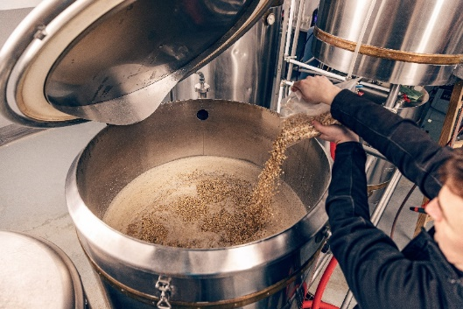
Emerging technologies are transforming the brewing process, enabling greater efficiency, precision, and sustainability.

Future trends in brewing equipment include:
- Automation and Control Systems: Advanced automation tools, such as programmable logic controllers (PLCs) and Internet of Things (IoT) devices, allow real-time monitoring and control of brewing parameters. These systems enhance consistency and reduce labor requirements.

- Artificial Intelligence (AI): AI-driven systems analyze brewing data to optimize processes, predict maintenance needs, and develop new recipes based on consumer preferences.

- High-Efficiency Equipment: Innovations such as energy-efficient boilers and compact heat exchangers reduce resource consumption without compromising performance.

Sustainability Innovations
Sustainability remains a driving force in microbrewery engineering.

Future developments focus on reducing environmental impact through:
- Carbon Capture Technology: Capturing carbon dioxide released during fermentation and repurposing it for carbonation or industrial use.
- Zero-Waste Systems: Designing breweries to achieve near-zero waste through comprehensive recycling, composting, and reuse strategies.
- Renewable Energy Integration: Expanding the use of solar, wind, and geothermal energy to power brewing operations.
- Circular Water Systems: Implementing advanced water recycling technologies to significantly reduce water consumption.

Packaging and Distribution Trends
As consumer demand for sustainable packaging grows, breweries are exploring innovative solutions:
- Eco-Friendly Packaging: Biodegradable cans, refillable growlers, and reduced-plastic alternatives are becoming more prevalent.
- Smart Packaging: QR codes and NFC tags on labels enable consumers to access product information, sustainability metrics, and interactive content.
- Localized Distribution Models: Many microbreweries are adopting hyper-local distribution networks to reduce transportation emissions and support local economies.

Emerging Brewing Processes
Advancements in brewing science are unlocking new possibilities for flavor, efficiency, and customization:
- Precision Fermentation: Biotechnology tools, such as CRISPR, enable the development of customized yeast strains for unique flavor profiles and enhanced brewing efficiency.
- Non-Alcoholic and Low-Alcohol Brewing: Improved methods for crafting flavorful non-alcoholic and low-alcohol beers are addressing growing market demand.
- Experimental Techniques: Techniques such as spontaneous fermentation and barrel aging are gaining popularity for creating distinctive craft beers.

10.2 Engineering for Scalability
Microbreweries often face challenges when scaling up production to meet increased demand.

Engineers are addressing scalability with:
- Modular Facility Design: Designing breweries with modular components that can be easily expanded or reconfigured.
- Dynamic Process Systems: Implementing flexible systems that adapt to varying production volumes without compromising quality.
- Digital Twins: Using virtual models of brewery operations to simulate and optimize production changes before physical implementation.

10.3 Regulatory and Market Trends
Regulations and market dynamics will continue to shape the future of microbreweries, including:
- Evolving Regulations: Stricter environmental and health standards will drive the adoption of advanced compliance technologies.
- Consumer Trends: Demand for sustainable practices, innovative flavors, and local products will influence brewery designs and operations.
- Global Expansion: As craft beer gains popularity worldwide, microbreweries will explore opportunities to establish operations in emerging markets.

10.4 Conclusion
The future of microbrewery engineering lies in the intersection of technology, sustainability, and innovation. Engineers must stay ahead of these trends to design facilities that are efficient, adaptable, and aligned with evolving industry demands.

By embracing advancements in automation, sustainability, and brewing science, microbreweries can continue to thrive as leaders in the craft beverage market.

Bibliography

- Brewers’ Handbook: The Complete Book to Brewing Beer. Ted Goldammer, Apex Publishers, 2008.
- Brewing Engineering: Advanced Techniques in Process Optimization. Edited by John Palmer and Colin Kaminski, Brewers Publications, 2020.
- Brewing Science and Practice. Bamforth, Charles W. Woodhead Publishing, 2006.
- Clean Water Act (CWA). United States Environmental Protection Agency (EPA).
- Environmental Protection Agency (EPA). "Best Practices for Sustainable Manufacturing."
- Microbrewery Case Studies: Real-World Engineering Challenges. Craft Beer & Brewing Magazine, 2023.
- Occupational Safety and Health Administration (OSHA). "Electrical Safety Guidelines for Industrial Facilities."
- Renewable Energy Integration in Breweries. Energy Efficiency and Brewing Journal, Issue 12, 2020.
- Sustainable Microbrewery Design. Brewing and Beyond Journal, Volume 15, Issue 3, 2021.
- The Brewers Association. "Guide to Starting a Brewery." Brewers Publications, 2023.
- Zoning Regulations for Industrial and Commercial Breweries. City of Portland, Planning and Zoning Department, 2022.

This course was prepared by Cadistics Courseware
All rights reserved

Educational Use Only
The content of this course is provided for educational purposes only. While every effort has been made to ensure the accuracy and reliability of the information presented, the author or publisher makes no guarantees regarding the completeness or applicability of the information to specific professional practices. Users are advised to consult additional resources and exercise professional judgment when applying the knowledge contained in this course.

